Cobb County School District
Quick Guide: Student Login for Naviance – At Home Access

- Go to: www.cobbk12.org
Find It Fast
- Click on Find It Fast
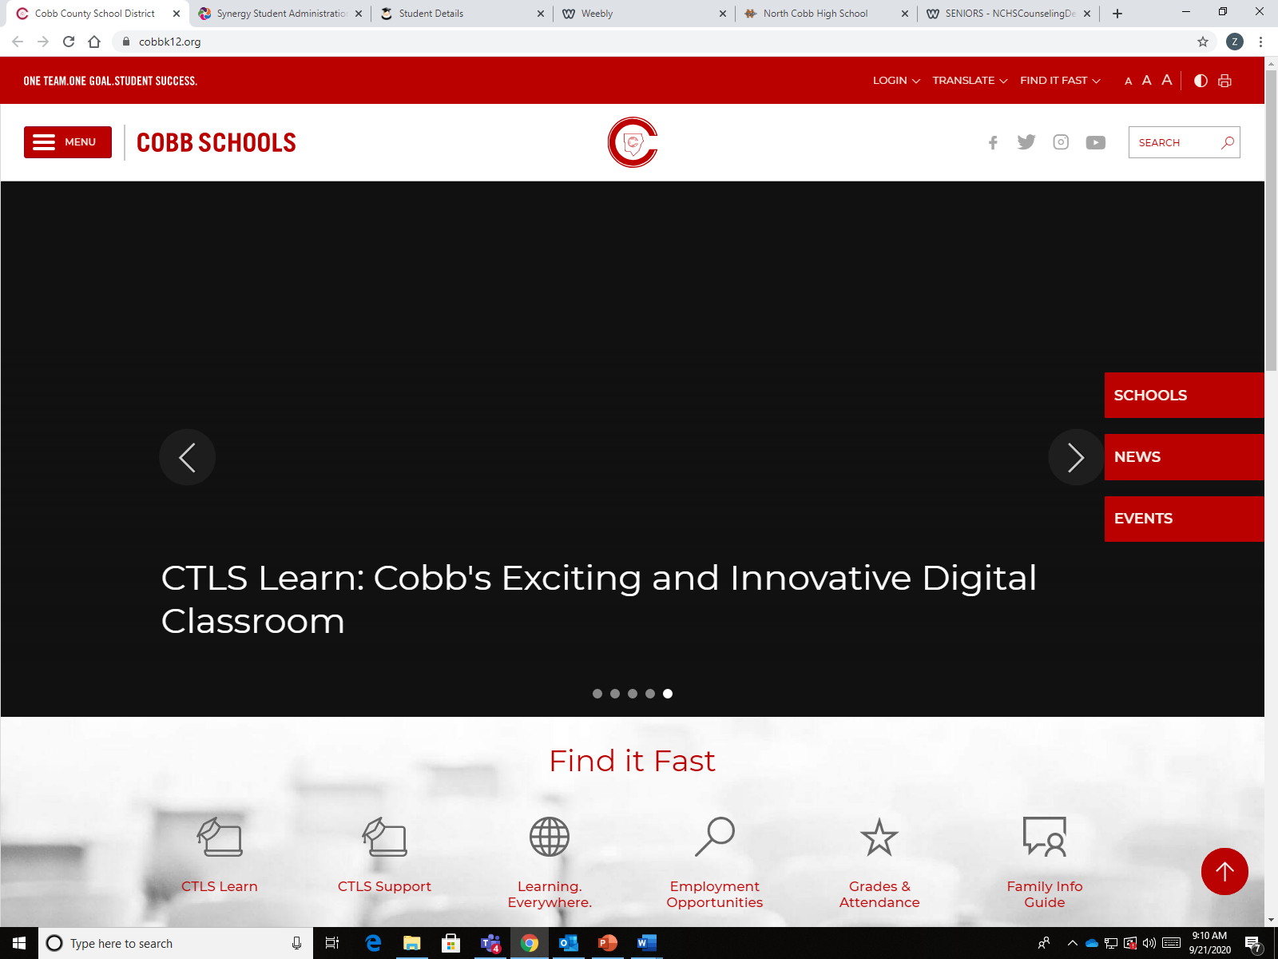

- Click on Naviance under Find It Fast
- Login using your Office 365 email login, firstname.lastname@students.cobbk12.org and password (what you use to log on a Cobb Computer)
- Parents log in using registered username and password- if you need an activation code email your student’s counselor.
***You must have a Naviance account to login.
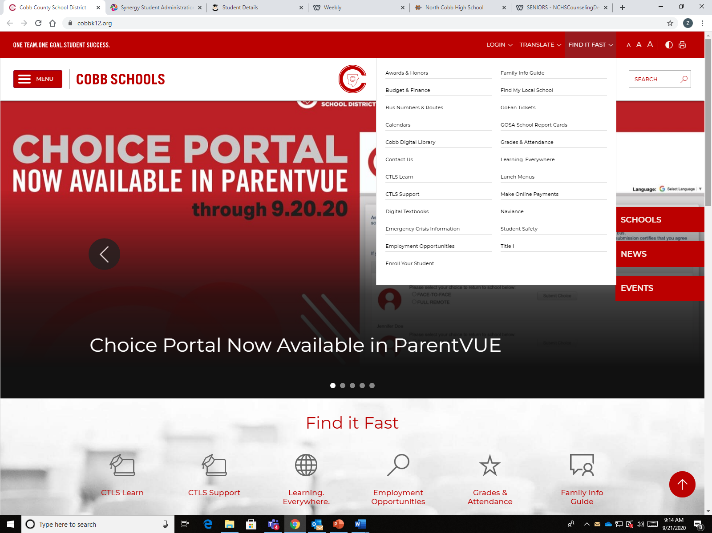
Naviance

