North Cobb High School
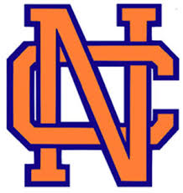
College Panel Night & Senior Night-What Comes Next!
Do you not know where you want to apply yet? Learn about various types of colleges, admissions requirements, financial aid and scholarships, to help you find the right fit!

Come learn about postsecondary options!

When: Wednesday, October 19th, 2022
5:30 p.m. College reps available
6:15 p.m. What Comes Next Presentation with Counselors
6:45 p.m. Q&A with College Reps
Where: NCHS Performing Arts Center

All Senior students and parents are invited to attend! Juniors are welcome to join as well!
Colleges attending:
