Cobb County School District
Quick Guide: Student Login for Naviance –In School Access

- Go to: www.cobbk12.org
Find It Fast
- Click on Find It Fast
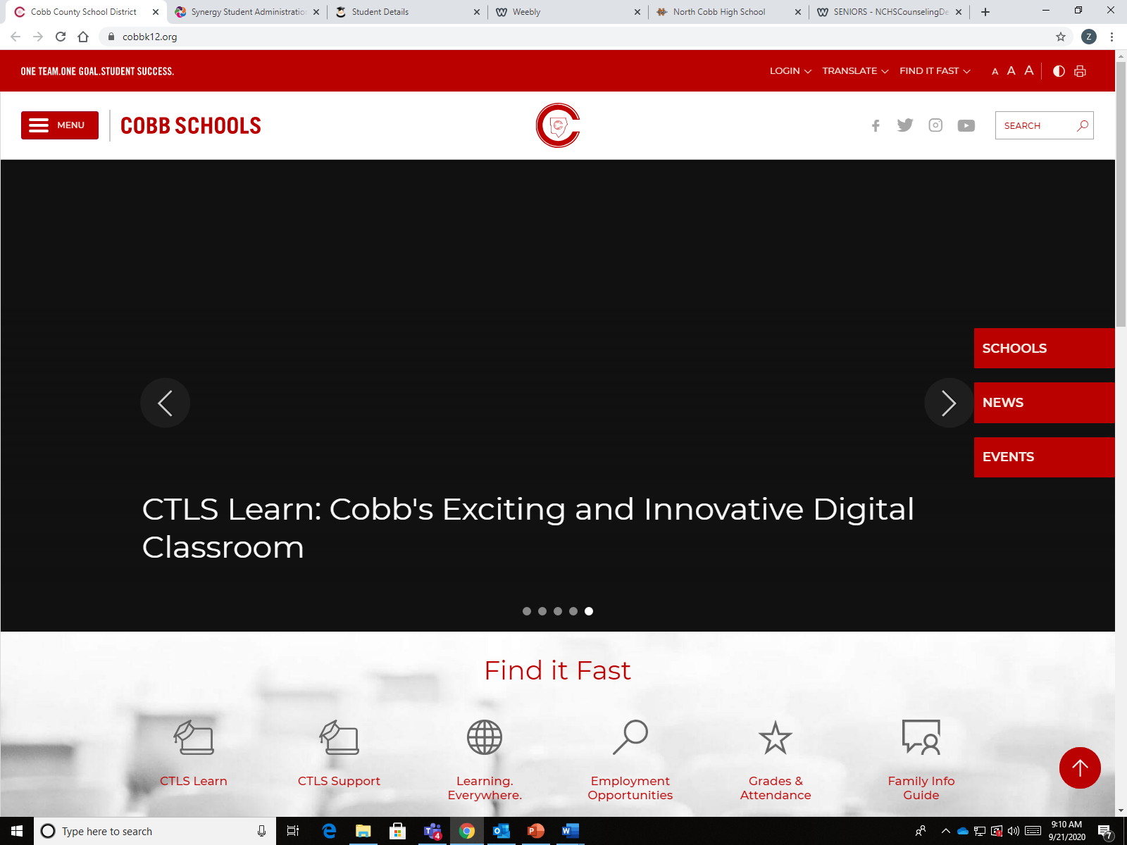

- Click on Naviance on the drop down menu under Find It Fast
- Login using your CCSD credentials. (Username and Password)
***You must have a Naviance account to login.

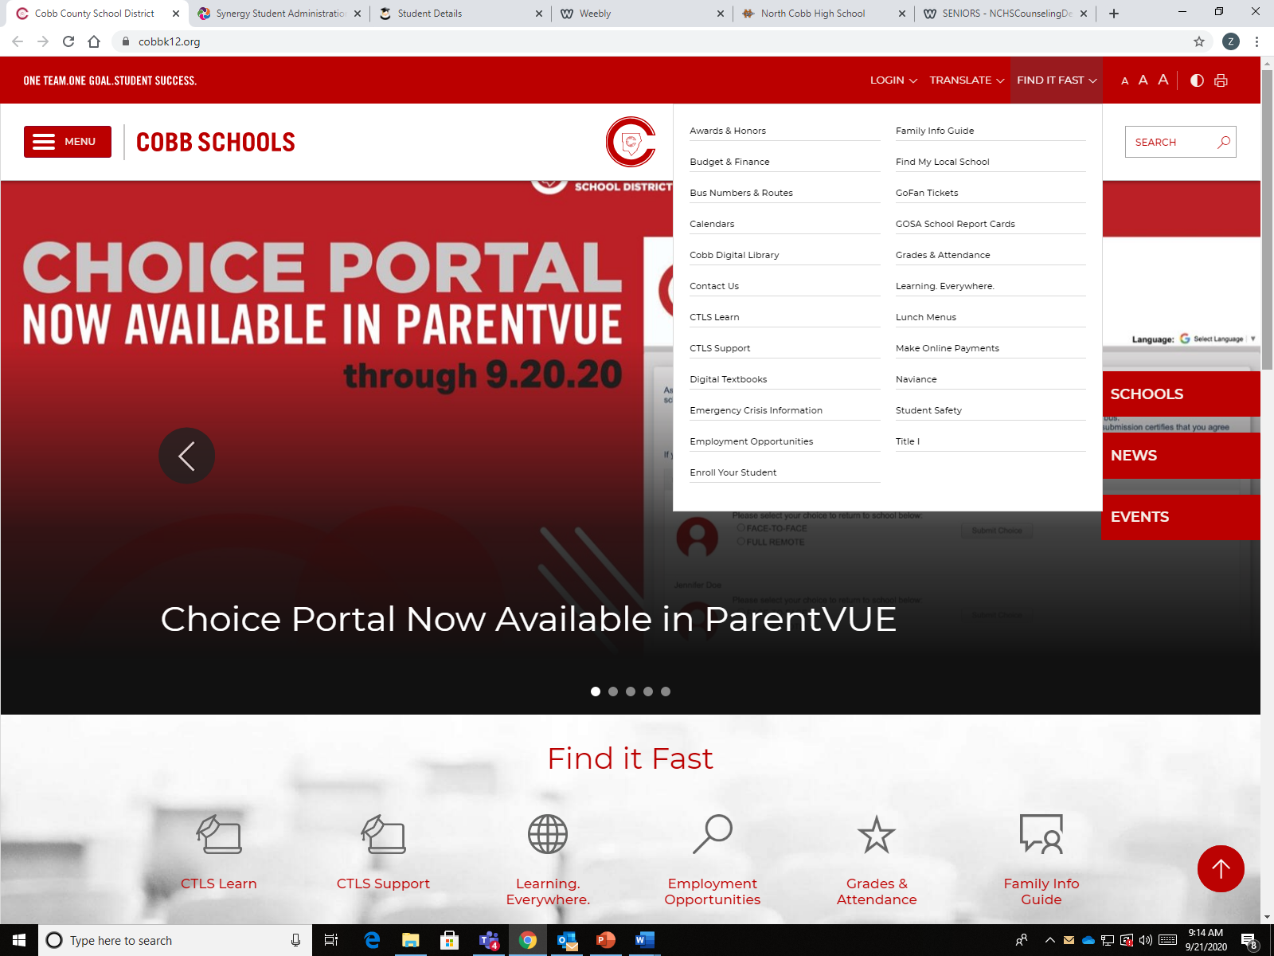
Naviance

