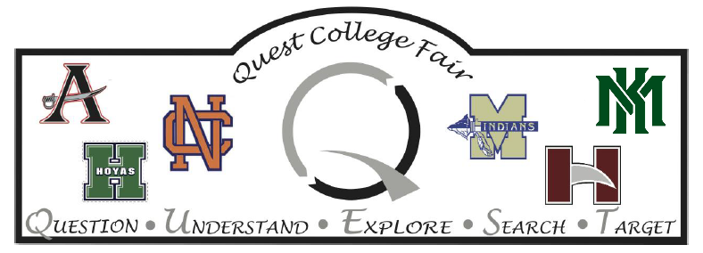
Monday, March 20, 2023
6:00 PM – 8:00 PM
All students are invited to use the QR Code or http://registerprobe.com/ to register.
Allatoona High School
Main Gym
3300 Dallas Acworth Hwy
Acworth, GA 30101
Who can attend? The QUEST College Fair is for high school students who are interested in exploring their educational opportunities after graduation—particularly sophomores, juniors, and their parents. Representatives from colleges, universities, and technical schools will be present. See what institutions are registered to attend: http://bit.ly/3XHRzuC

Workshop Sessions:
College 101  Room 1106  6:00 – 6:45 PM | College 101 en español  Room 1106  7:00 – 7:45 PM | NCAA Eligibility  Room 1302  6:00 – 6:45 PM | Kennesaw State University  Room 1303  7:00 – 7:45 PM | Military Academies  Room 1301  6:00 – 6:45 PM
Transition to College for Students with Disabilities  Room 1110  Drop-In | University of Georgia  Room 1108  6:00 – 6:45 PM  7:00 – 7:45 PM | Georgia State University  Room 1303  6:00 – 6:45 PM | Financial Aid  Room 1405  7:15 – 8:00 PM | Chattahoochee Tech  Room 1301  7:00 – 7:45 PM

